Table of Contents
Merkin Peripheral Neuropathy and Nerve Regeneration (PNNR) Center Research Grant Application 2
Overview 2
Seed grant application requirements: 4
Cover Letter 4
Research Proposal 4
Budget and justification 4
Mandatory meetings 4
Reporting 5
Submission package 5
Micro-grant application requirements: 6
Research Proposal 6
Budget and justification 6
Reporting 6
Submission package 7
Merkin PNNR Center Seed Grant Application Details 8
Section A- General Information 8
Section B- Contact information 9
Section C - Proposal 9
Section D- Budget 10
Section E- Supplemental documents 10
Merkin PNNR Center Seed Grant Application Checklist 11
Merkin PNNR Center Micro-grant Application Details 12
Section A: Contact Information 12
Section B: Proposal 12
Section C: Supplemental documents 13

Merkin Peripheral Neuropathy and Nerve Regeneration (PNNR) Center Research Grant Application

Overview

The Johns Hopkins Merkin Peripheral Neuropathy and Nerve Regeneration (PNNR) Center has been established to advance peripheral neuropathy (PN) and nerve regeneration research, deepen the understanding of the conditions and their causes, and develop viable therapies.

As part of the JHU Merkin PNNR Center’s mission to provide support to research, we offer research grants to qualified applicants. Our goal is to help researchers explore novel ideas and answer questions related to peripheral neuropathy and nerve regeneration. If you are a researcher (junior faculty or senior post-doctoral fellow who finished two years of training at Johns Hopkins) committed to enhancing the science behind peripheral neuropathy and nerve regeneration, we encourage you to submit your grant application to the Merkin PNNR Center. Please note that duplicate or overlapping funding from any other private or public source for the same project is not allowed.

Research proposals will be carefully vetted by the Scientific Advisory Board (SAB). The Board will evaluate each proposal based on the investigator’s experience, the project plan, and the research environment, as well as the project’s ability to be translated into treatments for people with PN.

Types of Proposals

In FY24, the Merkin PNNR Center is giving grants in two different mechanisms.

Seed grants: We are requesting submissions for high-risk, high-reward pilot projects that probe the mechanistic underpinnings of axon degeneration and Schwann cell dysfunction in peripheral neuropathies as well as impediments to successful nerve regeneration. Novelty of the proposed ideas as well as likelihood for successful transitioning to external funding will be key selection criteria for funding. For this funding mechanism, Researchers may request funding for 1 or 2 years (max $75K/year), depending on the scope of the proposal.

Micro-grants: We are requesting submissions for single-purpose projects to generate preliminary data or complete an ongoing research activity related to peripheral neuropathies and nerve regeneration. Types of projects that will be supported by this mechanism include generating omics datasets or transgenic mice, purchasing costly reagents for a specific experiment or small equipment. These applications will be reviewed in an expedited manner and a funding decision will be made within 4 weeks of the application. Researchers may request funding for up to 6 months (up to $20K), depending on the scope of the proposal.

Submission timeline

Seed grants: The proposal submission period is between July 3, 2023 and August 13, 2023. 11:59 pm EST. Award notifications will be sent out by October 31, 2023. The earliest expected project start date is December 1st, 2023.

Micro-grants: Micro-grant applications will be accepted on a rolling basis through July 2, 2024.

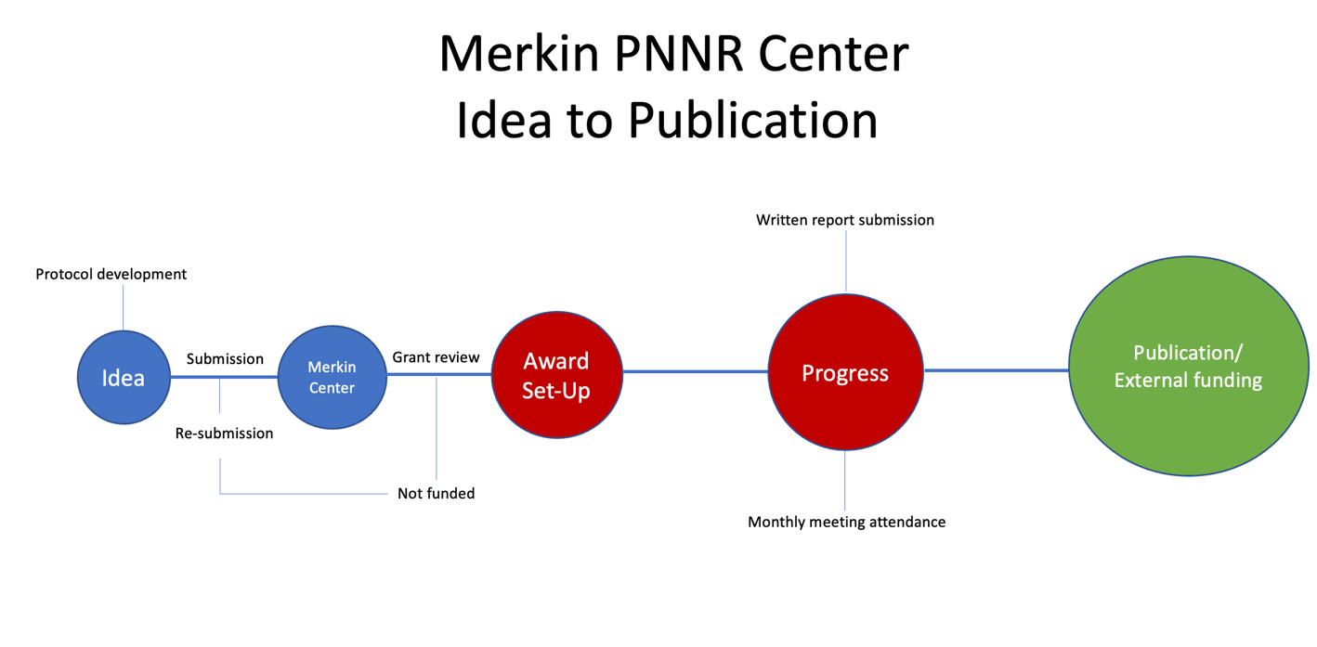

Seed grant application requirements:

Cover Letter

Cover letter should include the following information and be maximum 500 words:
- A strategic reason for the advisory board to consider your proposal:
  - Identify the problem to be addressed and the needs to be met by the project.
  - Describe your project’s objectives, activities, staffing, collaborators, timelines and explain how the design will enable you to address the problem or need.
- Total funds requested
- Other funding

Research Proposal

Research proposal should include the following information and be maximum 1,500 words:
- Abstract (maximum 250 words),
- Specific aims,
- Background and significance (i.e., rationale),
- Preliminary results (if available), and
- Research design and methods (including expected results and alternate strategies)
- Data management
- Statistical analysis
- Project timeline and deliverables

Budget and justification

Please include the following budget information in your submission and be aware of the budgetary limitations outlined below.

- Budget period: Please specify the start and end dates of each budget year separately (e.g., March 15, 2024, to March 14, 2025).
- Annual budget: The budget for each year should not exceed $75,000.
- Detailed budget justification: Provide a comprehensive explanation for each expense category. Note that faculty salary is not allowed.
- Second-year funding: If applicable, funding for the second year is contingent upon successful progress during the first year.

Mandatory meetings
Merkin PNNR Center will hold monthly Grant Holders’ meetings. It is required that grantees and/or their senior staff attend these meetings during the award period. The purpose of these meetings is to provide an open discussion platform among the research scientists to exchange ideas, promote collaboration and improve the projects’ success. Attendance at minimum 8/12 meetings per year is required to continue to receive funding.

Reporting

Interim and final project progress and expenditure reports will be required for every grant awarded. It is important to design your evaluation process at the outset and begin to collect data from the beginning of the project.

Publication

All manuscripts (including meeting abstracts and research papers in review) resulting from this research project must be submitted to the Merkin PNNR Center after acceptance for publication. Any such publication or public presentation with reference to your investigations should clearly indicate that these investigations were carried out through funding provided by the Merkin Peripheral Neuropathy and Nerve Regeneration (PNNR) Center.

Submission package
1. Cover Letter
2. Grant application
3. Budget and justification
4. Supplemental documents

Online submission portal will be available on the Merkin PNNR Center website on July 3, 2023.

Contacts
Lale Akca, MBA for submission related inquiries
Ahmet Hoke, M.D., Ph.D. for scientific inquiries

Micro-grant application requirements:

Research Proposal

Research proposal should include the following information and be maximum 1,000 words, including budget and justification:
- Proposal title and short name
- Purpose
- Strategic reason
- Proposal summary
- Institutional approvals (if applicable)
- Status of other funding

Budget and justification

Proposal budget information to include in your submission and budgetary limitations are as follows.
  - Budget period up to 6 months (e.g., November 1, 2023, to May 1, 2024).
  - Total funds requested (not to exceed $20,000).
  - A detailed budget justification for each expense category (salary is not allowed).

Reporting

A final project progress and expenditure report will be required for every grant awarded. It is important to design your evaluation process at the outset and begin to collect data from the beginning of the project.

Publication

All manuscripts (including meeting abstracts and research papers in review) resulting from this research project must be submitted to the Merkin PNNR Center after acceptance for publication. Any such publication or public presentation with reference to your investigations should clearly indicate that these investigations were carried out through funding provided by the Merkin Peripheral Neuropathy and Nerve Regeneration (PNNR) Center.

Submission package
- Grant application
- Budget and justification
- Supplemental documents, if applicable

Online submission portal is available on the Merkin PNNR Center website.

Contacts
Lale Akca, MBA for submission related inquiries
Ahmet Hoke, M.D., Ph.D. for scientific inquiries

Merkin PNNR Center Seed Grant Application Details

Grant cycle 23-DF/C2

Section A- General Information
Full title: [your project’s full title]

Short name: [identify a three-word short name for your project that will be used in correspondence]

Purpose: [summarize the project purpose in 3-4 sentences directed at non-scientific audience]

Strategic reason: [identify the problem to be addressed and the needs to be met by the project]

Proposal summary: [describe your project’s objectives, activities, strategies, staffing, collaborators, timelines and explain how the design will enable you to address the problem or need]

Total funds requested: [the project period and total funds you are requesting]

Institutional approvals: [details about any institutional approvals you have obtained here, if applicable. For example: IRB approval status and number, IACUC approval status and number, IBC #]

Other funding: [information about alternative/supplemental other funding you have obtained or planning to obtain for this proposal. Include any internal or external funding and their status]

Section B- Contact information

Principal Investigator, Co-Investigator(s) and staff:

Name:
Degree(s)/Credentials:
Title:
Institution:
Department:
JHED ID:
Phone #:
E-mail address:
Street Address:

Section C - Proposal

Abstract: [one paragraph, maximum 250 words. Briefly summarize your project, the research plan, and the expected outcomes]

- Specific aims: [your project’s specific aims in detail]

- Background and significance, rationale: [discuss current relevant work and highlight the significance of your project. Explain why your project is interesting and significant. Provide prior research done in this area and the necessary background leading up to your research hypotheses that you’ll be testing in your project]

- Preliminary results, if applicable: [provide information about any preliminary findings]

- Research design and methods: [provide information about your overall methodological approach and give details of your data collection plan. Include your sample size estimate, inclusion/exclusion criteria, and any procedures, and tools you plan to use for data collection]

- Data management: [provide information about your data management plan such as data collection, data ownership, standards and formats planned to be used, data security measures, sample collection methods, and storage]

- Statistical analysis: [provide detailed information about the statistical plan and procedures that will be used to analyze your data]

- Project timeline and deliverables: [summarize the project timeline to effectively implement your project including tasks and activities to be performed, roles and responsibilities of your research team and milestones and deadlines to be met]

Section D- Budget

Entire budget period: [specify the budget period; i.e: March 15, 2024, to March 14, 2026]

Requested total amount: [specify the total cost of your project for the entire project period]

Expenses: [itemize your expenses by category for each budget year]

Budget justification: [provide detailed explanation of each budget category and how the funds will be used for each budget year]

Section E- Supplemental documents

Bio-sketches: [NIH formatted bio-sketch for the principal investigator and each coinvestigator(s)]

Departmental support letters (optional): [provide letter(s) of support from department
chair/program director/supervisor/mentor]

Submit your proposal electronically using the online portal located on the Merkin PNNR Center’s website anytime between July 03,2023 and August 13,2023.

Merkin PNNR Center Seed Grant Application Checklist

This checklist will help you organize the information you are required to submit as part of your proposal. Please make sure that all required items on the checklist are submitted in your submission package. Submitting the checklist is optional.

- Section A: General information
  - Proposal full title
  - Proposal short name
  - Purpose
  - Strategic reason
  - Summary
  - Total funds requested
  - Institutional approval documentation, institutional number
  - Status of alternative/supplemental other funding
- Section B: Contact Information
  - Principal investigator
  - List of Co-investigators and roles
  - List of staff and roles
- Section C: Proposal (not to exceed three pages)
  - Abstract (one paragraph)
  - Specific aims
  - Background, significance, and rationale
  - Preliminary results (if available)
  - Research design and methods (including expected results and alternate strategies)
  - Data management plan
  - Statistical analysis
  - Project timeline and deliverables
- Section D: Budget and justification
  - Budget period (e.g., December 1, 2022, to November 30, 2023)
  - Number of years
  - Annual total budget
  - Requested total amount
  - Budget justification for each budget category
- Section E: Supplemental documents
  - Bio-sketches for the principal investigator and co-investigator(s)
  - Departmental support letters (optional)

Merkin PNNR Center Micro-grant Application Details

Grant cycle: 23-DF/MG

Section A: Contact Information
Principal Investigator, Co-Investigator(s) and staff:
Name:
Degree(s)/Credentials:
Title:
Institution:
Department:
JHED ID:
Phone #:
E-mail address:
Street Address:

Section B: Proposal

Full title: [your project’s full title]

Short name: [identify a three-word short name for your project that will be used in correspondence]

Purpose: [summarize the project purpose in 3-4 sentences directed at non-scientific audience]

Strategic reason: [explain why this funding is critical]

Proposal summary: [describe the experiment where the requested resource is needed and provide justification for the resource]

Total funds requested: [insert the project period and total funds you are requesting]

Budget justification: [Insert a detailed budget justification for each expense category]

Institutional approvals: [provide details about any institutional approvals you have obtained here, if applicable. For example: IRB approval status and number, IACUC approval status and number, IBC #]

Other funding: [provide information about alternative/supplemental other funding you have obtained or planning to obtain for this proposal. Include any internal or external funding and their status]

Section C: Supplemental documents

Bio-sketches: [NIH formatted bio-sketch for the principal investigator and each coinvestigator(s)]

Departmental support letters (optional): [provide letter(s) of support from department
chair/program director/supervisor/mentor]

Applications will be accepted on a rolling basis. Submit your proposal electronically using the online portal located on the Merkin PNNR Center’s website anytime between July 18,2022 and July 16,2023 EST 11:59pm.

