Vaginoplasty Hair Removal Template
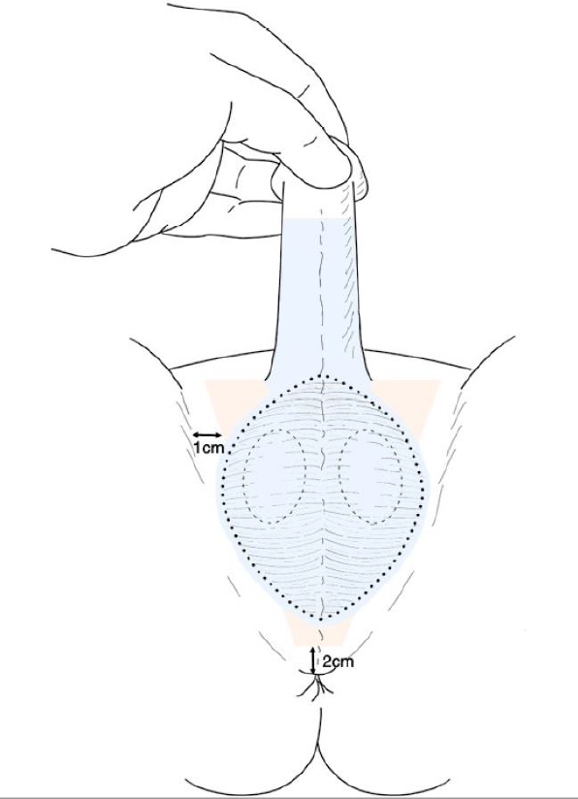

Area 1: Shaded in blue: Entire scrotum and penile shaft
Area 2: Shaded pink triangular region: Groin and perineum, all skin more than 1cm from groin crease (beginning at the top of the penile shaft and ending 2cm above the anus)

