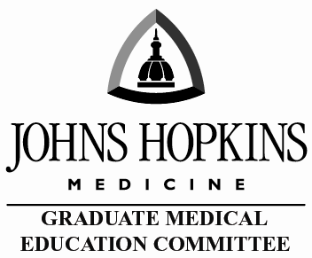 | Johns Hopkins Hospital and Johns Hopkins University School of Medicine  Graduate Medical Education (GME)  Expectations and Guidelines for Preparation of Residents as Teachers

Purpose:
Residents and fellows often serve as teachers and role models for medical students. Thus, it is critical that they be prepared for their roles.
- Accreditation Council on Graduate Medical Education (ACGME) Common Program Requirement IV.B.1.e).(1).(d) expects residents to demonstrate competence in educating patients, families, students, residents, and other health professionals.
- The Liaison Committee on Medical Education (LCME) which accredits medical schools has expectation for residents to serve as teachers of medical students (Standard 9.1). In accordance with these accreditation requirements and expectations, residents who supervise or teach medical students must be familiar with and receive orientation on the educational objectives and required clinical encounters of the course or clerkship and be prepared for their roles in teaching and assessment

Requirements:
- Institutional - In accordance with accreditation requirements and institutional expectations, residents who supervise or teach medical students must be familiar with and receive orientation on the educational objectives and required clinical encounters of the course or clerkship and be prepared for their roles in teaching and assessment. The JHUSOM will provide access to learning materials to introduce and educate all residents and fellows applicable to their roles as teachers of medical students.

The Residents as Teachers module in myLearning is required of all incoming trainees as part of the GME onboarding process and is monitored centrally:
https://lms14.learnshare.com/dashboard/dash.home.aspx?Z=UGyaxR424LIiP1vLtS8kkP1SflAH0aCEuQcLWf8dU9Rt5qXzf89xuxb%2bHwNw12aM The course provides residents with an overview of their roles as medical student educators. Points of emphasis include the central components of a framework for effective teaching, important institutional policies, and the goals and objectives for each of the core clerkships.

- Departmental – Each department is required to regularly provide clerkship specific learning objectives, performance expectations, pertinent education policies, and instruction in use of assessment tools and additional customized resident as teachers programs to ensure effective teaching and maintenance of a positive learning environment. Residents should have access to and regularly receive feedback on their teaching skills and contributions.

