- Login to my.JH: Navigate to the url:https://my.jh.edu and click Login.
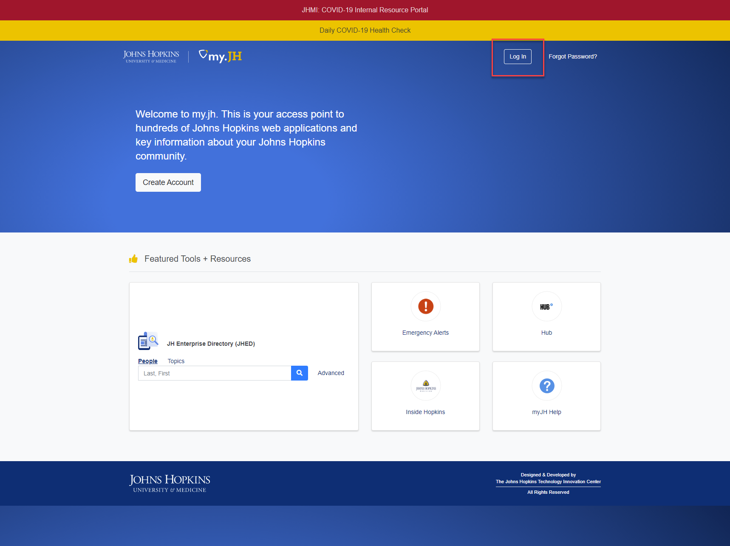

- Click on your profile picture / user name in the top right hand corner of the page then select My Profile.
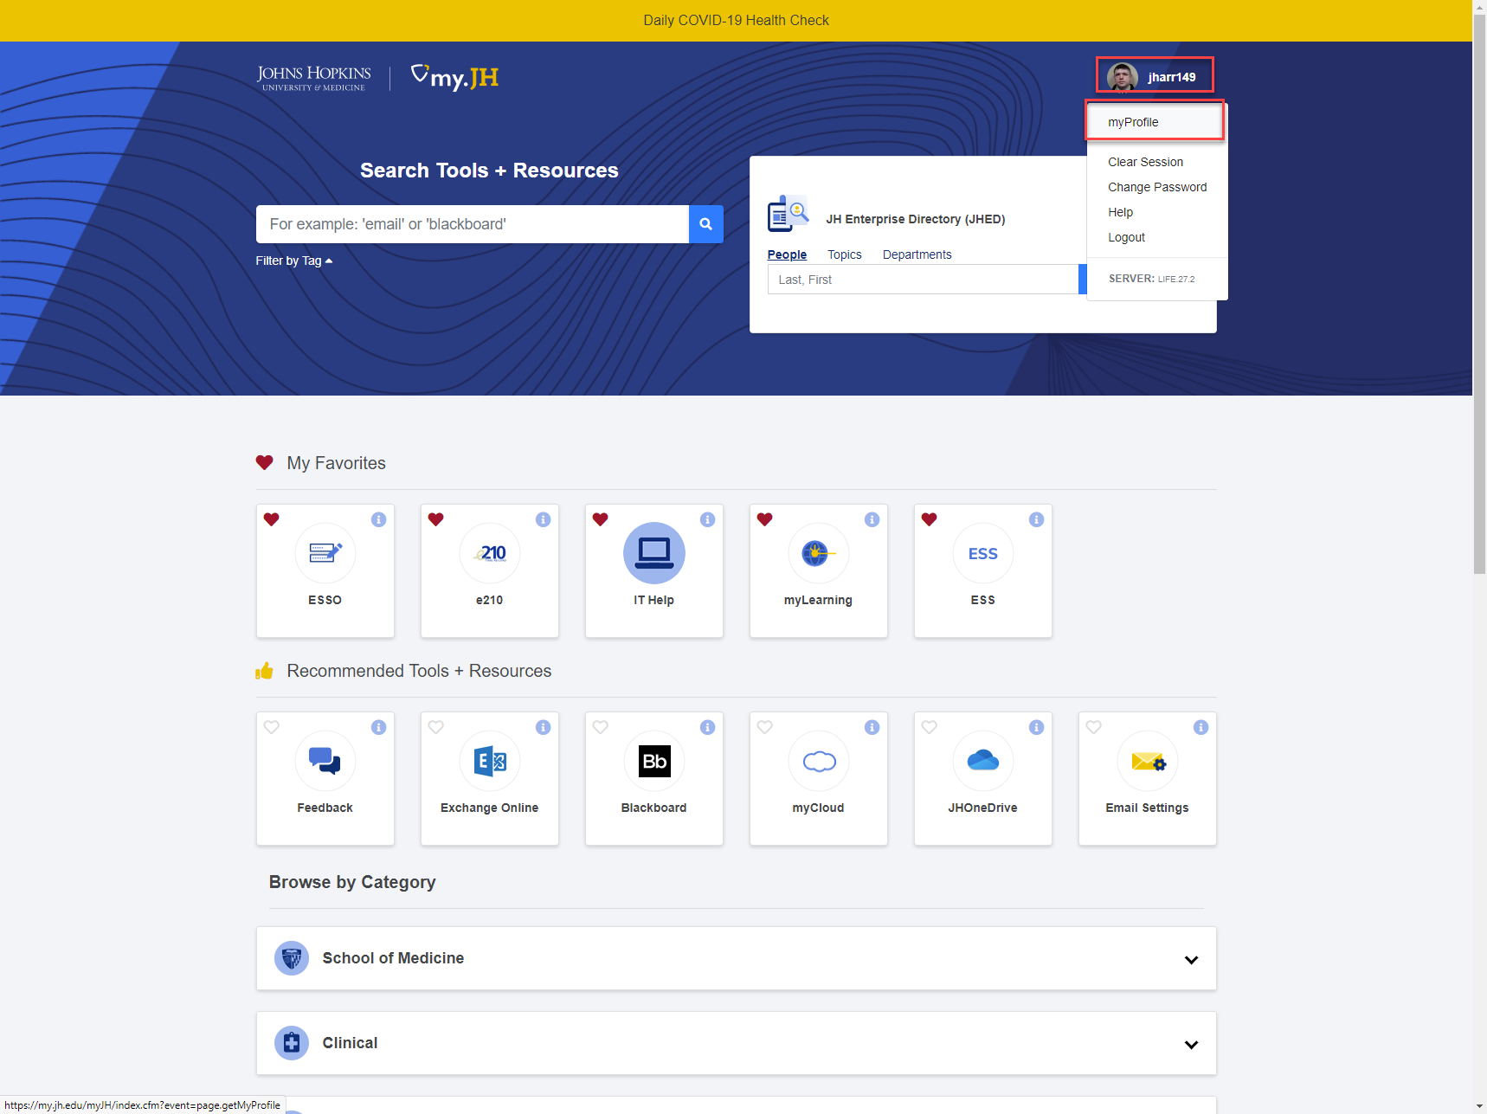

- In the myProfile tab, update “Preferred First Name” field, which is located in the middle of the page:
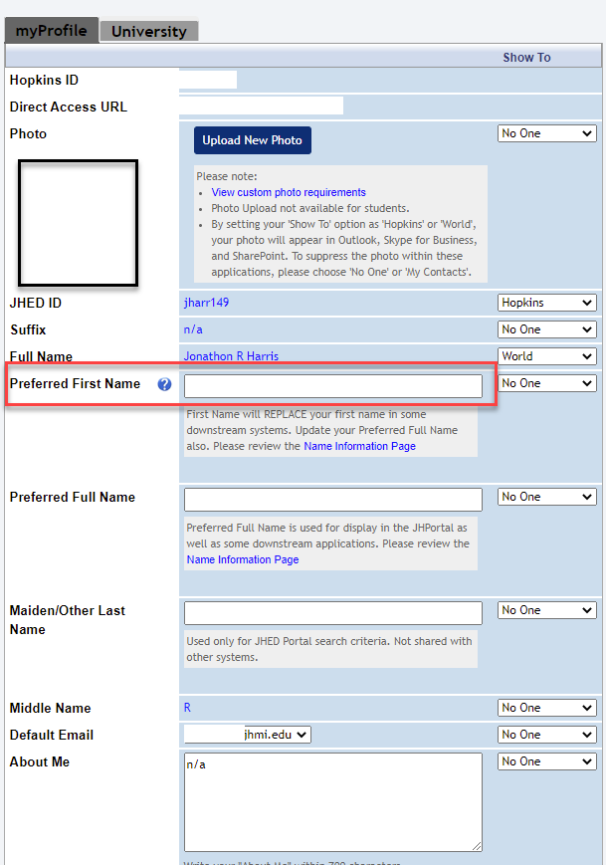

- Update and click Save My Profileat the bottom of the page
